**DEPARTMENT OF INFORMATION TECHNOLOGY**

**Course Name and Code:** Data Structures Lab **(**ITL302)

**Semester:** III (SYIT)

**Academic Year:** 2024-25 (Odd Semester)

**Experiment No. 02**

**Aim:** Implementation of Queue using Array for real-world application.

**Code:**

#include<stdio.h>

#define MAX 100;

int Q[100],Front=-1,Rear=-1,x,n=

100;

void Enqueue();

void Dequeue();

void Display();

int main(){

int op;

while(op!=5){

printf("\nThe operation can be performed are:");

printf("\n 1)Enqueue\n 2)Dequeue\n 3)Display\n");

printf("Enter Your choice :");

scanf("%d",&op);

switch(op){

case 1 : Enqueue();

break;

case 2 : Dequeue();

break;

case 3 : Display();

break;

default : printf("Exit The Program");

}

}

}

void Enqueue(){

if (Rear >= n - 1){

printf(" The Queue is Overflow ! \n");

}

else

{

printf(" Enter the element to insert: ");

scanf("%d", &x);

Rear++;

Q[Rear] = x;

Front++;

printf("The %d is Inserted Into The Queue\n",x);

}

}

void Dequeue(){

if(Front == -1){

printf("The Queue Is Underflow !\n");

}

else

{

printf("The Deleted Element Is %d",Q[Front]);

Front++;

Rear--;

}

}

void Display(){

if(Rear == -1){

printf("The Queue Is Empty\n");

}

else

{

printf("The Elements In the Queue Are:\n");

for(int i = 0; i<= Front ; i++){

printf("%d\n",Q[i]);

}

}

}

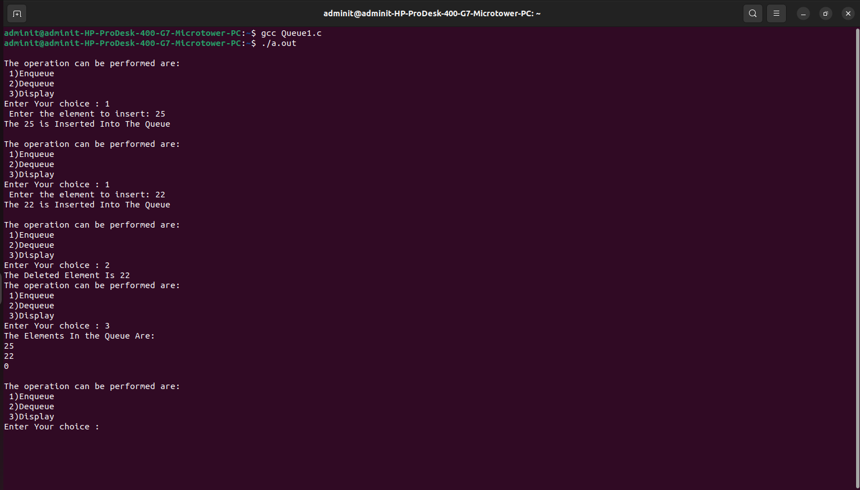

**Submitter Details:-**

**Name:** Abhinav.S.Dasari

**Roll No:** 16

**Div/Batch :** A/ S-2